Cataract Surgery in Dogs

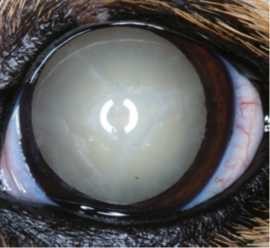
What are Cataracts?
White mature cataract

Cataracts are a relatively common cause of vision loss in dogs. A cataract is a clouding of the lens inside the eye, which prevents an image from reaching the retina, leading to impaired or complete loss of vision. They are usually caused by genetics, diabetes, aging or trauma. Fortunately, cataract surgery is a highly effective treatment option for restoring vision in appropriate cases, but isn’t suitable for every eye or every patient.

What is Cataract Surgery?

Cataract surgery in dogs is a procedure that involves the removal of the cloudy lens using the same technique used in people, called phacoemulsification. Dogs require a general anaesthetic, whereas most people do not. In most cases, replacing the natural lens with an artificial lens (intraocular lens, or IOL) can restore good focus.

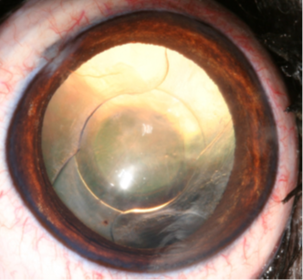
Is My Dog a Candidate for Cataract Surgery?

Not all dogs with cataracts are suitable candidates for surgery. The ideal candidate typically has:

Good general health (for example a relatively stable diabetic dog)

No significant other eye diseases that could affect recovery, such as glaucoma, retinal degeneration and severe uveitis

Your own vet can do a pre-anaesthetic assessment including blood tests and clinical examination with heart check. Sometimes a dental procedure is required.
Cataract surgically removed; intraocular lens in place

Post-Surgical Care

After surgery, your dog will be hospitalised for one night to monitor recovery and intraocular pressures.

Medication: Eye drops are required ideally four times daily for a week, then three times daily for 3 weeks, then twice daily for a month and then once daily for a month. In most cases, they are then discontinued but some eyes require longterm eye drops. There is an anti-inflammatory liquid required orally for about one month and possibly antibiotic pills for a few days, but the medication prescribed varies on a case-by-case basis.

Buster collar: This is required to prevent them from rubbing their eyes for one week.

Limited activity: Avoid excessive jumping or rough play for four weeks to allow the eye to heal properly. After the first week, lead walks can gradually be extended. The use of a harness is recommended to reduce pressure on the neck.

Follow-up Appointments: Regular check-ups are important to monitor healing and address any complications early. Standard check-ups are scheduled one week, one month and three months post-operatively, but we are available for advice or extra check-ups when required.

Risks and Considerations

While cataract surgery is generally safe, as with any surgery, there are some risks:

Glaucoma: Increased intraocular pressure can cause potentially serious blindness and pain. Many precautions are taken to reduce the risk but all dogs with cataracts and with cataract surgery are susceptible. Sometimes longterm eye drops are required to manage the condition, and in the worst cases, removal of the eye to alleviate pain is required (done about once annually).

Inflammation: Inflammation is expected after surgery, but it can usually be managed with medication. A few cases get more severe inflammation and need additional medications.

Lens complications: In rare cases, the implanted lens may become dislodged requiring further treatment. In very young dogs, lens cells can proliferate, very occasionally requiring a second procedure to remove opacity.

Retinal issues: If the retina is already damaged or degenerating, vision will not be fully restored.

Other complications: Uncommon complications include corneal ulceration, infection, retinal detachment and intraocular haemorrhage.

Your veterinary ophthalmologist will discuss these risks with you and take all necessary precautions to minimise them.

Cost of Cataract Surgery

The cost of cataract surgery varies depending on the complexity of the case, the veterinary clinic, and the type of lens used. On average, the procedure can cost between € 3300-3500 for one eye or € 4,300-4500 for both eyes done together, with additional costs for the initial pre-surgical exam, and any additional medications. Three months of follow-up visits (usually at one week, one month and three months post-op) are included, along with medications that will be sufficient for most but not all cases.

Success rate of Cataract Surgery

Success is defined as comfortable eyes with good vision. The rate is approximately 90 % six months after surgery, and approximately 80 % longterm.

Pre-Surgery Instructions

Your dog should be fasting from 10 pm the night before, but water is allowed at all times.

Please bring the following items:

Three meals of their normal food.

Any medication they are currently receiving; enough for two days.

A harness, collar and lead.

A blanket, if you wish.

For diabetic patients:

Give a normal meal and insulin dose at a normal time the night before.

Bring three meals, and their insulin and syringes with you the morning of the surgery.

Don’t give insulin the morning of surgery, we will administer an appropriate dose.

If you have any questions or concerns, please do not hesitate to contact us on info@eyevet.ie. Our team is here to help guide you through the process and ensure the best possible outcome for your dog.

